The Role of a Lloyd’s Broker
Damascus, June 2005
www.uib.co.uk UIB United Insurance Brokers
George J Kabban

Definition and Origin of a “Broker”
Definition: bro·ker (brō'kər) n.
One that acts as an agent for others, as in negotiating contracts, purchases, or sales in return for a fee or commission.
Generally, an insurance broker is the agent of the assured. He owes a duty of care to the insurer(s) and is, classically, remunerated through a commission paid by the insurer(s), unless otherwise agreed.
WORD ORIGINS:
[Middle English, from Anglo-Norman brocour, abrocour; akin to Spanish alboroque, ceremonial gift at conclusion of business deal, from Arabic al-barka, the blessing, colloquial variant of al-baraka : al-, the + baraka, blessing, divine favor (from bāraka, to bless).]
WORD HISTORY:
The English word broker is first found in Middle English in 1355, several centuries before we find instances of its familiar compounds pawnbroker, first recorded in 1687, and stockbroker, first recorded in 1706.
Accreditation Of A Lloyd’s Brokers
1. The professionalism and quality of the firm of brokers.
2. The skills, knowledge, experience and suitability of the directors and
employees.
3. The firm’s knowledge and understanding of how business is conducted in the London market.
4. The firm’s trading history and financial standing.
5. The firm’s ability to bring business to the Lloyd’s market.
6. The firm’s ability and willingness to comply with the principles and
standards for the conduct of business in the London insurance market.
In assessing the suitability for accreditation at Lloyd’s of a firm of Brokers the following are considered:
Characteristics / Duties of a Lloyd’s Broker
• Most regulated end of the broking industry
• Clients’ and insurers’ monies are safest in the hands of a Lloyd’s Broker (IBA / Solvency )
• Obliged to only select solvent insurers as assessed by the broker’s security committee
• Obligatory full disclosure of participating security/insurers
• Most professional in the avoidance/declaration of conflicts of interest (Risk Taking v/s Broking)
• Professional Indemnity / Errors & Omissions
• Must maintain and monitor on-going education & training of staff
• A heavier burden to carry, but more rewarding, in the long run for all

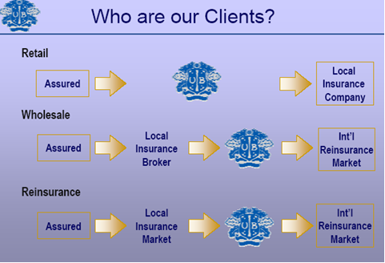

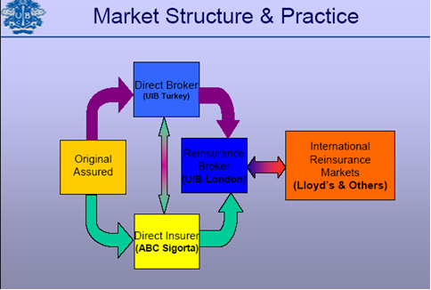

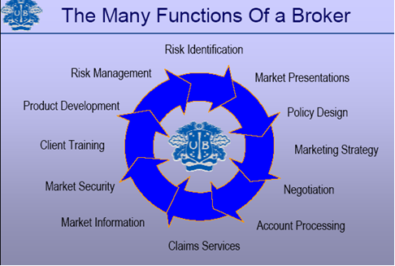

The Missing Link?
• Corporate Brokers are still not admitted in several Arab countries – but changing.
• Many local insurers were/remain short-sighted and fight the emergence of brokers as competitors, rather than welcoming a synergistic and symbiotic relationship.
• For greater market growth and penetration professional corporate brokers are the main answer.
The Future Outlook
• Regionally, greater acceptance of direct or retail corporate broker involvement.
• Internationally, a tendency towards a more consultative role and reassessment of brokers’ remuneration and greater transparency
• Broker spin-offs in the short-term, further consolidation in the medium term
• Continued pressure on brokers to add value

